# Store Sales and Profit Analysis

**Summary:**

The analysis of store sales and profit involves examining a retail store's performance in terms of its revenue and profitability. This process aids businesses in pinpointing areas requiring enhancement and using data-driven insights to refine their operations, pricing, marketing, and inventory management strategies. Ultimately, the goal is to boost revenue and foster growth.

**Analysis:**

**Output:**

I. Descriptive Analysis:

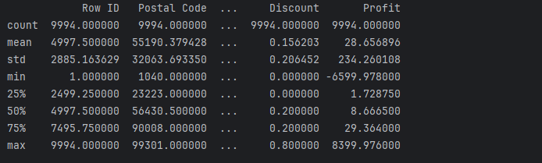

**II.** Monthly Sales Analysis

**Output**

III. Sales by Category

**Output**

IV. Sales by sub-category

**Output**

V. Monthly Profits

**Output**

VI. Profit by Category

**Output**

VII. Profit by Sub-Category

**Output**

VIII. Sales and profit analysis by customer segments

**Output**

**Inference:**

The store enjoys greater profits from consumer product sales, whereas the sales-to-profit ratio indicates superior profitability from corporate product sales.

IX. Sales profit by segments

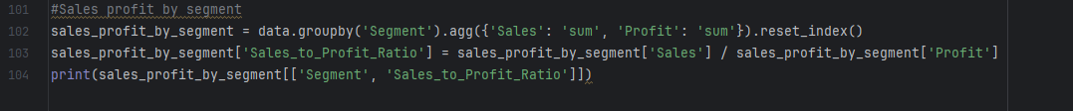

**Output**

**Conclusion**

Analyzing sales and profits aids businesses in pinpointing areas for enhancement, enabling them to make informed decisions based on data. This optimization spans operations, pricing, marketing, and inventory management strategies, all aimed at fostering revenue growth.